Major General Marke F. Gibson, USAF (ret)
Senior Advisor on UAS

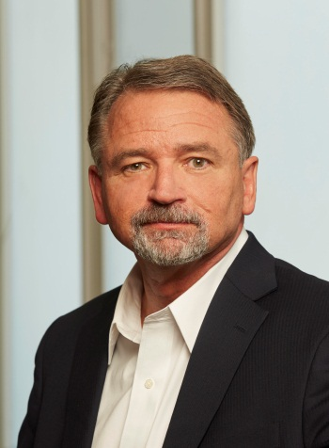
Marke Gibson Senior Advisor on Unmanned Aircraft Systems (UAS) Integration (ADA-3) to the Deputy Administrator of the Federal Aviation Administration. Gibson is responsible for providing executive direction and high level leadership to the FAA with responsibility for oversight of the work related to UAS. Gibson will develop and deliver business and strategic plans for enterprise-level UAS initiatives and analyze integration progress.
Prior to joining the FAA Gibson served as the Executive Director of the NextGen Institute. The primary role of NGI is to provide a mechanism through which the private sector actively engages with the USG in defining, developing, and implementing NextGen. In his position Gibson promoted the NextGen Institute throughout the industry created awareness and gained new support for NextGen initiatives. Gibson led two UAS Spectrum working groups, an FAA Global Leadership Roundtable, and commenced work on an ADS-B initiative on behalf of the Deputy Administrator.
Prior to joining the NGI Gibson served as the President and CEO of a highly successful aerospace consulting practice in Colorado. He retired in 2011 as the Air Force’s Director of Current Operations and Training. In that role, he led the standup of a new Cyber career field and its integration into Air Force operations. He also worked on behalf of the Secretary and Chief of Staff of the Air Force ways to better integrate Unmanned Aerial Vehicles (UAV’s) into our national airspace. This involved continuous engagement within the interagency (FAA and Homeland Defense) and numerous congressional delegations. As the Director of Training, General Gibson was also responsible for the standup of a separate career field and unique training path for those who fly Air Force Remote Piloted Aircrafts (RPA’s) today.
General Gibson was in Cheyenne Mountain on 911 and worked as the Director of NORAD Operations to establish many of our Nation’s integrated defense measures that are still in effect today. Besides his last posting within the Pentagon Major General Gibson has extensive operational leadership experience as an Air Force pilot and Commander. His expertise includes aerospace operations (both military and civil), UAS operations, cyber operations, command and control (C2), and homeland defense.
Major General Gibson earned a bachelor’s degree in Economics and Management from the United States Air Force Academy. He also received a master’s degree in Business Administration from the University of Northern Colorado and a master’s degree in National Security Affairs from the National War College. He completed a national security fellowship with Syracuse University and trained in lean six-sigma management through the University of Tennessee.

