Anh N. Duong
Program Executive Officer
Unmanned Aerial Systems
Department of Homeland Security – Science & Technology Directorate

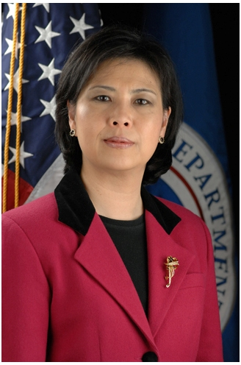
Mrs. Duong, a Senior Executive, leads the DHS Science &Technology’s (S&T) Program Executive Office for Unmanned Aerial Systems (PEO UAS), directing all S&T UAS and Counter-UAS efforts. At the interagency level, she co-chairs the Working Group on CUAS Technology with the White House Office of Science & Technology Policy, under the auspices of the National Security Council.

Prior to her current role, Mrs. Duong led S&T’s Borders and Maritime Security Division with a focus on understanding the technical dimension of border, maritime, and cargo security in order to transform science & technology into operating capabilities. Before coming to DHS, Mrs. Duong spent 25 years working for the Department of the Navy. She served as Science Advisor to the Deputy Chief of Naval Operations for Information, Plans and Strategy, and the Director of the Naval Criminal Investigative Service, focusing on anti-terrorism and force protection. Prior to that, she was Director for Science and Technology at the Naval Surface Warfare Center – Indian Head Division, where she was best known for her expertise in high explosives and undersea weapons.

Mrs. Duong’s professional excellence and commitment to public service is widely recognized. She was named an outstanding federal employee by the 111th Congress, honored as an outstanding American Citizen by Choice by the US Customs and Immigration Service, and received numerous prestigious awards including the Service to America Medal for National Security, the Dr. Arthur Bisson Award for Naval Technology Achievement, and the Navy Superior Civilian Service Medal. She was featured in an award-winning documentation film (Why We Fight), a book (Changing Our World: True Stories of Women Engineers), on television (as a mastermind behind US thermobaric weapons in the “Future Weapons” Series on Discovery and Military Channels), as well as in numerous newspapers and magazines including the Wall Street Journal, Washington Post, the Sun, Newsweek, etc.

